AWS SQS & AWS MQ Hands-on Lab Guide
Expected Deliverables
By the end of this lab, you will:
- Understand the concepts of AWS SQS and AWS MQ.
- Learn real-world use cases.
- Perform complete hands-on implementation.
- Capture screenshots.
- Prepare architecture diagrams.
- Record observations.

AWS SQS (Simple Queue Service)
Objective
Implement Amazon SQS to decouple two applications.
Example:
Application A
│
▼
Amazon SQS Queue
│
▼
Application B
Producer sends messages.
Consumer receives messages.

What is Amazon SQS?
Amazon Simple Queue Service (SQS) is a fully managed message queue service that enables different applications to communicate asynchronously.
Instead of Application A directly talking to Application B,
Application A sends messages to SQS.
Application B processes messages whenever it is ready.
This avoids downtime.

Real World Example
Online Shopping
Customer places an order
↓
Order goes to SQS Queue
↓
Inventory Service reads message
↓
Payment Service reads message
↓
Shipping Service reads message
Everything works independently.

Types of SQS
1. Standard Queue
- Unlimited throughput
- Best effort ordering
- At least once delivery
Use Case
- Logging
- Email processing
- Image processing

2. FIFO Queue
FIFO = First In First Out
Features
- Exactly once processing
- Ordered delivery
Use Case
- Banking
- Financial Transactions
- Payment Systems

AWS Services Used
- Amazon SQS
- IAM
- EC2 (Optional)
- AWS CLI

Architecture
Producer

│

▼

+----------------------+
| Amazon SQS |
| Queue |
+----------------------+

│

▼

Consumer

Prerequisites
- AWS Account
- IAM User
- AWS CLI Installed
- Region selected
Example
us-east-1

Task 1 – Create SQS Queue
Open
AWS Console
↓
Search
SQS
↓
Create Queue
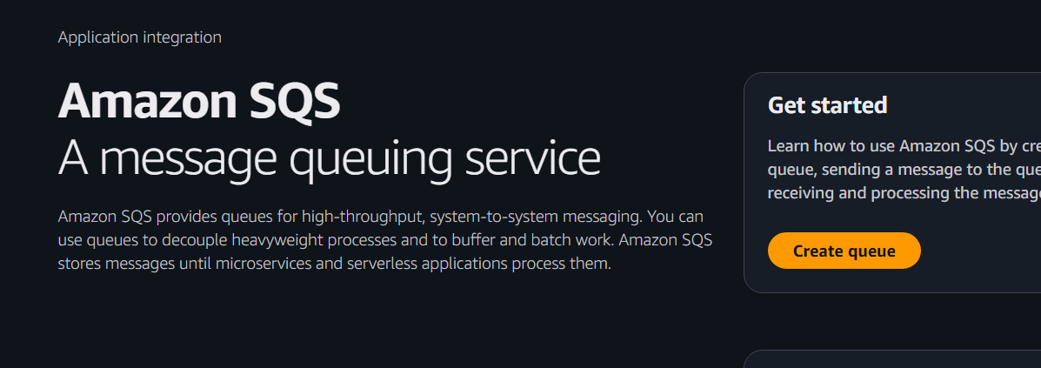

Choose
Standard Queue
Queue Name
DevOps-Queue
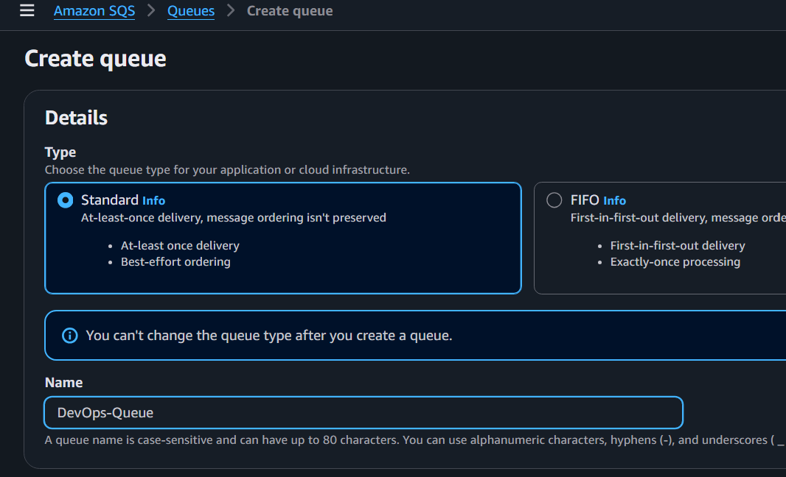
Visibility Timeout
30 Seconds
Message Retention
4 Days
Maximum Message Size
256 KB
Delivery Delay
0 Seconds
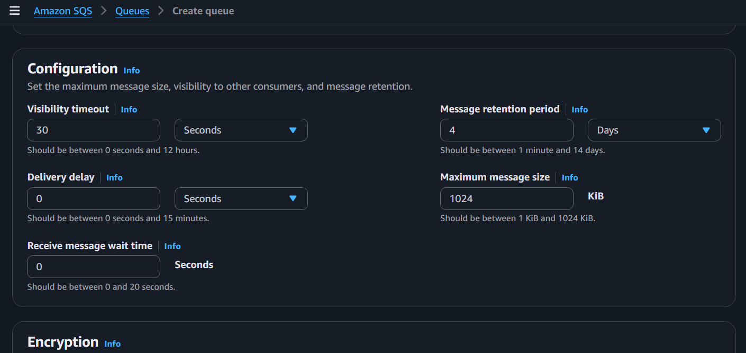

Encryption
Enable
SSE-SQS
or
AWS KMS
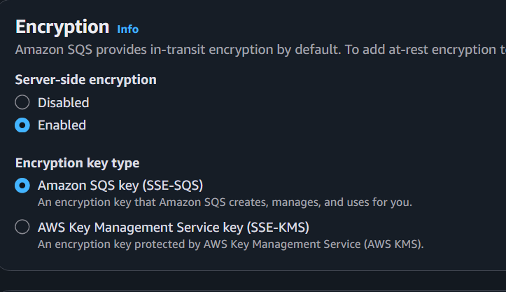
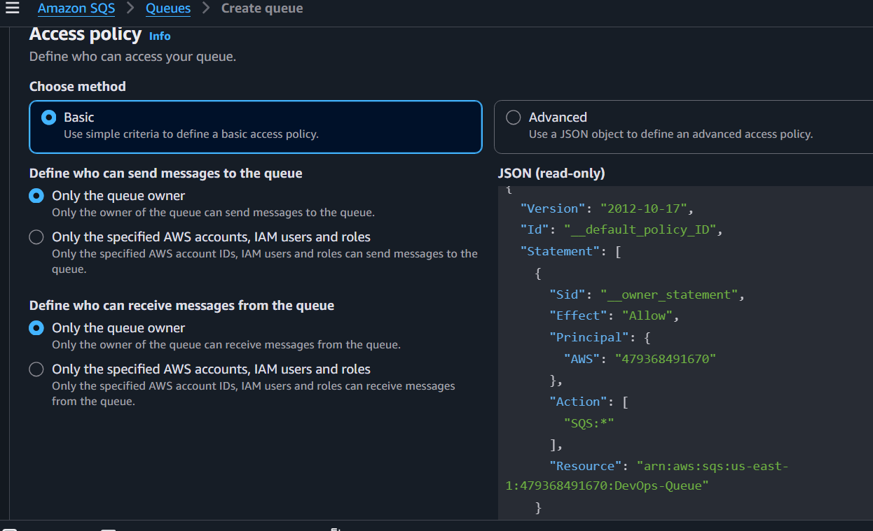

Click
Create Queue
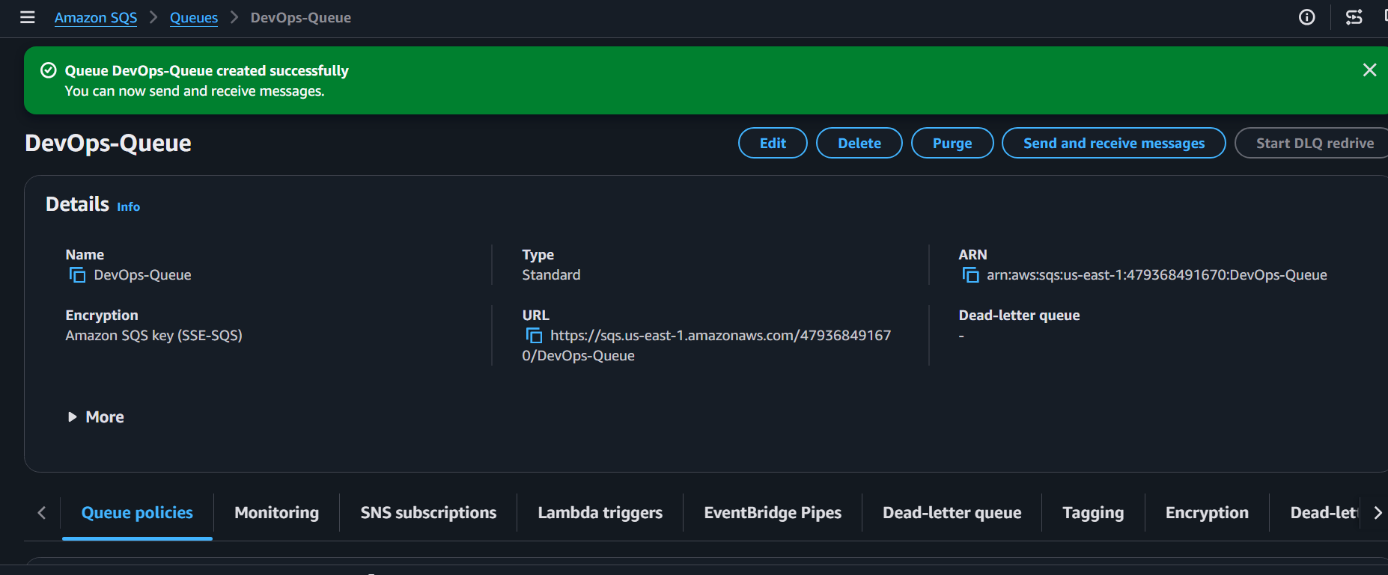
Queue Created Successfully

Task 2 – Send Messages
Open Queue
↓
Send and Receive Messages
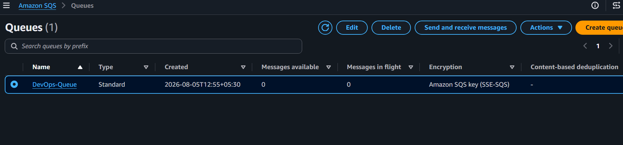

Message Body
Hello DevOps Team
Send Message
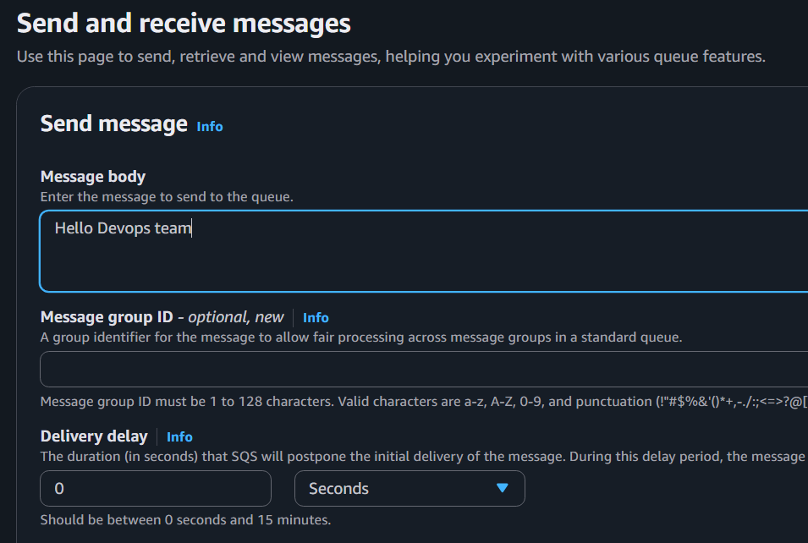
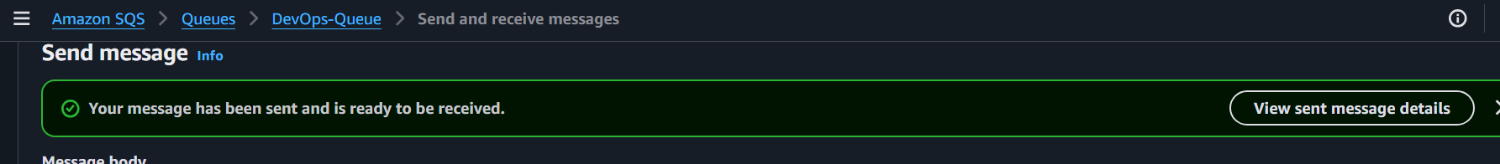

Again send
Build Successful

Again send
Deployment Completed

Messages Sent
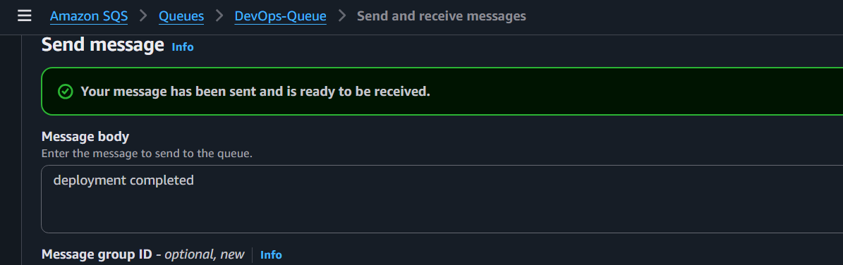

Task 3 – Receive Messages
Open Queue
↓
Poll for Messages
Receive Messages
You should see
Hello DevOps Team
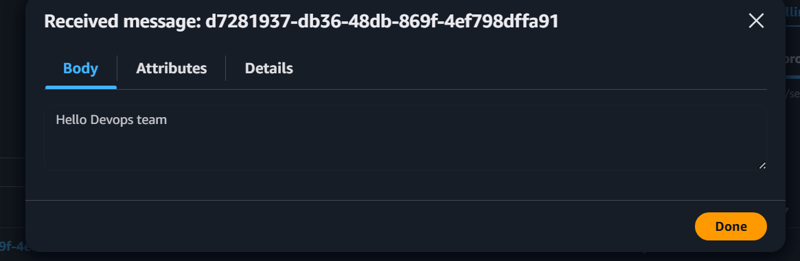
Build Successful
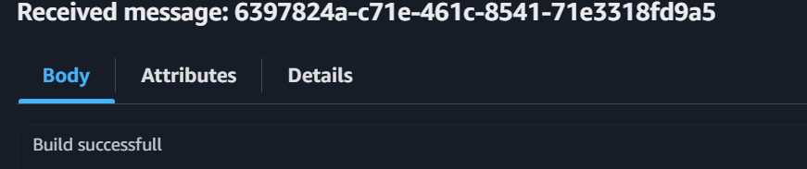
Deployment Completed
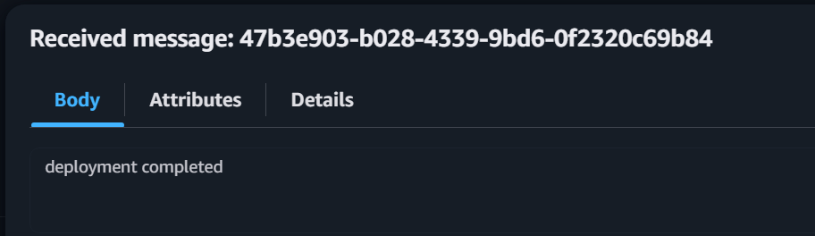

Delete Messages
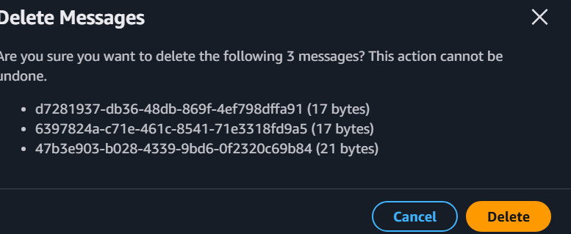
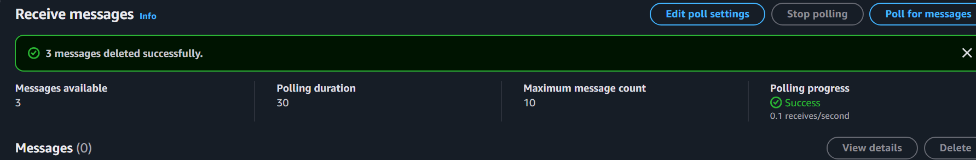

Task 4 – Create FIFO Queue
Create Queue
Choose
FIFO
Queue Name
orders.fifo
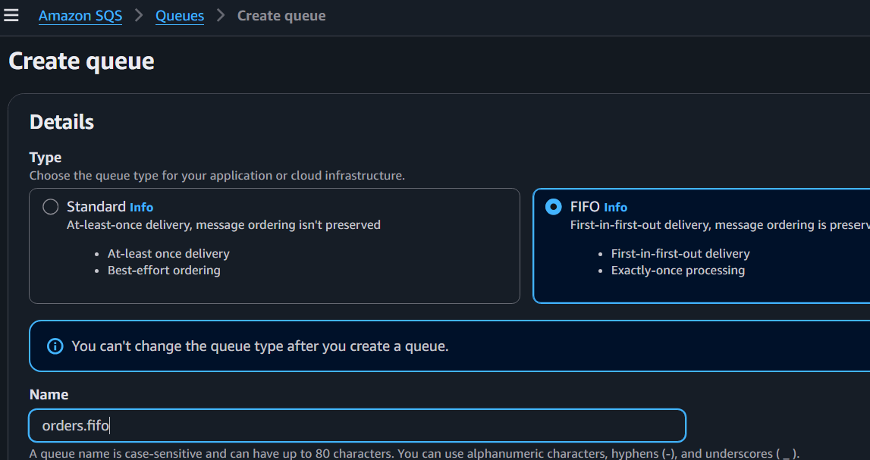
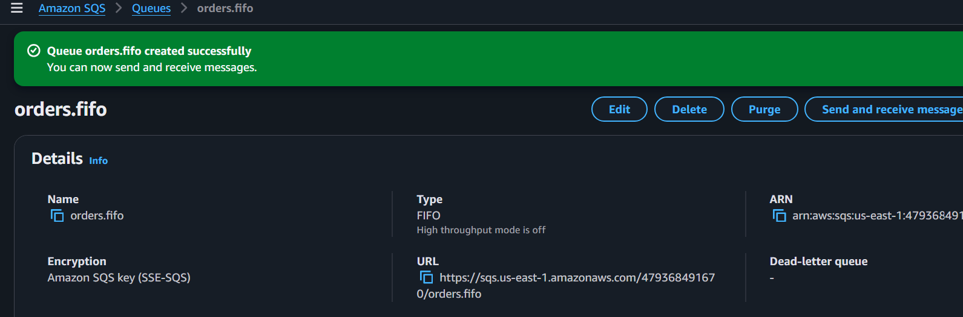
Content Based Deduplication
Enable
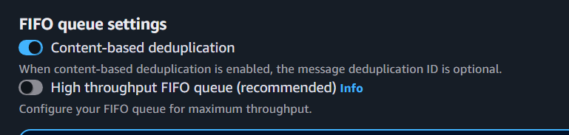

Send
Order 1
Order 2
Order 3
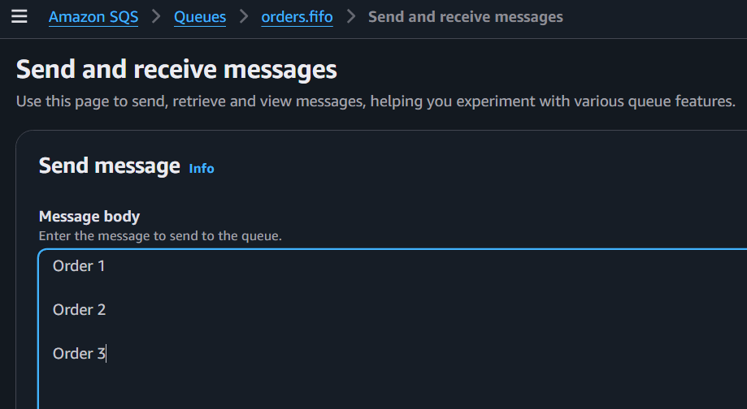
Receive
Observe order.
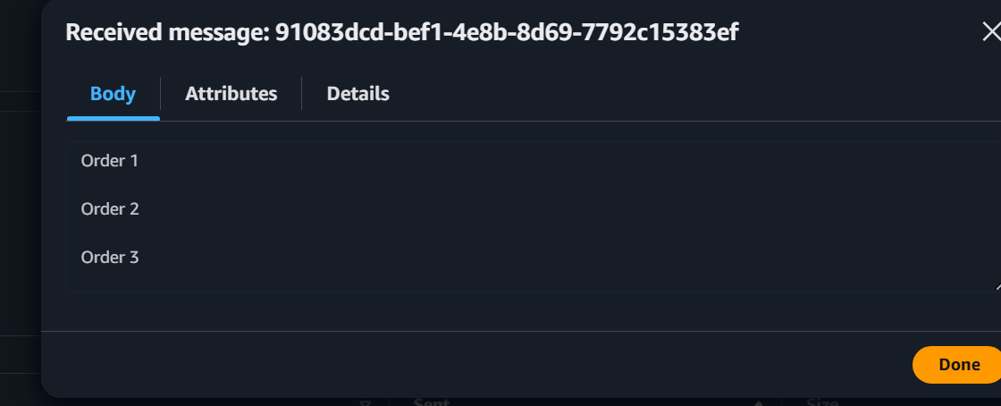

Task 5 – AWS CLI (optional)
List Queues
aws sqs list-queues
Expected
QueueUrls

Get Queue URL
aws sqs get-queue-url \
--queue-name DevOps-Queue
Send Message
aws sqs send-message \
--queue-url YOUR_QUEUE_URL \
--message-body "Hello from CLI"
Receive Message
aws sqs receive-message \
--queue-url YOUR_QUEUE_URL
Delete Message
aws sqs delete-message \
--queue-url YOUR_QUEUE_URL \
--receipt-handle RECEIPT_HANDLE
CLI Output
Task 6 – Enable Dead Letter Queue (DLQ)
Create Queue
DeadLetterQueue
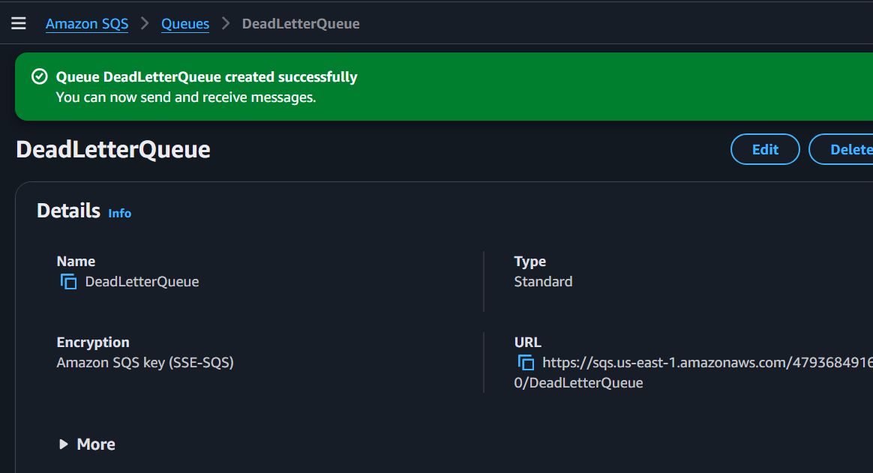
Attach the DLQ to the Main Queue
1. Open Devops-Queue.
2. Click Edit.
3. Go to the Dead-letter queue section.
4. Enable Use a dead-letter queue.
5. Select DeadLetterQueue.
6. Set Maximum receives to: 5
7. Save changes.
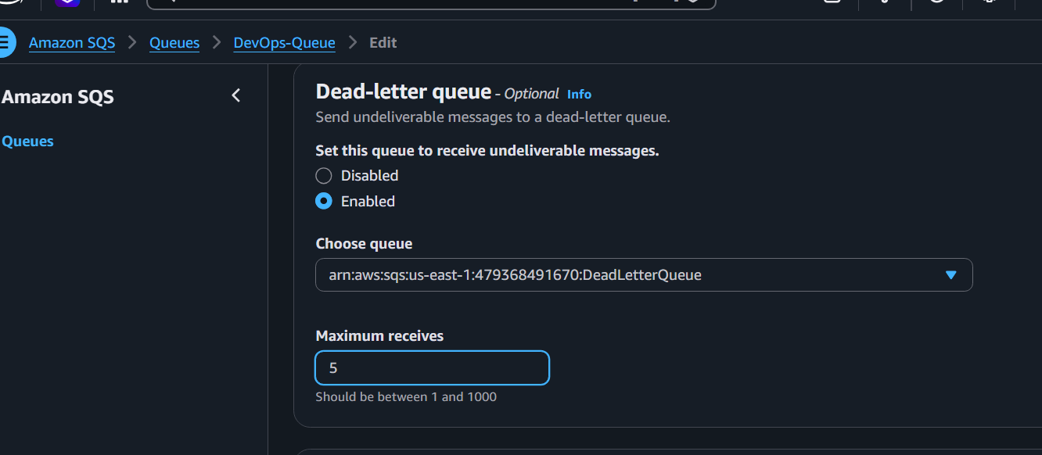
Purpose
Messages failing five times move to DLQ.
DLQ Configuration
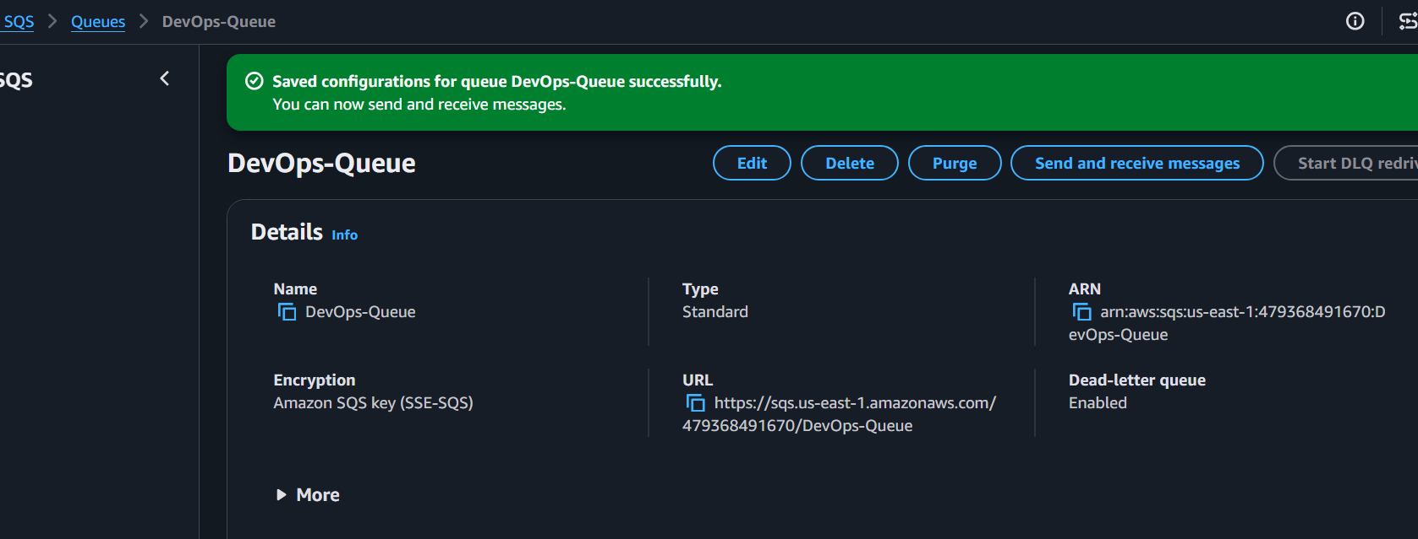
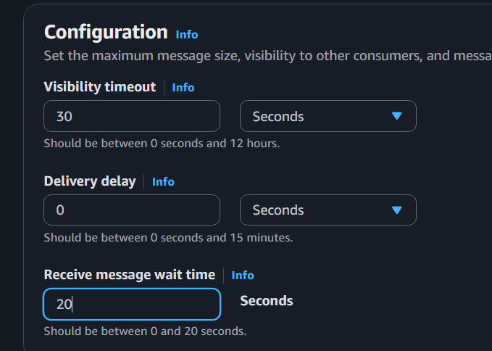
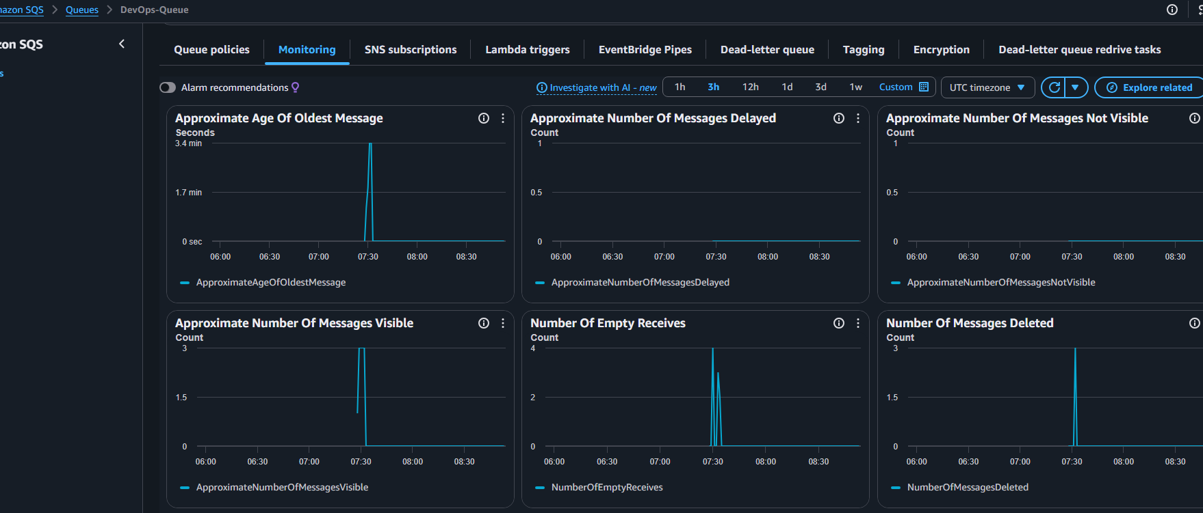

Observations
- Standard Queue doesn't guarantee ordering.
- FIFO preserves order.
- SQS improves reliability.
- Queue stores messages temporarily.
- DLQ stores failed messages.
- Producer and consumer are independent.

Advantages
- Fully Managed
- Highly Available
- Auto Scalable
- Secure
- Reliable
- Pay per Request

Disadvantages
- Message size limit (256 KB)
- Polling latency
- FIFO throughput lower than Standard

AWS MQ
Objective
Create an Amazon MQ broker and connect clients.

What is AWS MQ?
Amazon MQ is a managed message broker service.
Supports
- ActiveMQ
- RabbitMQ
Unlike SQS,
Applications maintain persistent connections with the broker using messaging protocols.

Real World Example
Banking System
ATM
↓
Amazon MQ
↓
Core Banking
↓
Notification Service
↓
Audit Service

Use Cases
- Enterprise applications
- Legacy Java applications
- Financial Systems
- Healthcare
- ERP

Architecture
Application A

│
▼
+----------------------+
| Amazon MQ |
| ActiveMQ Broker |
+----------------------+
│
▼

Application B

Prerequisites
- IAM User
- VPC
- Public or Private Subnet
- Security Group
- Internet Access (for testing if applicable)

Task 1 – Create Amazon MQ Broker
Open AWS Console
↓
Amazon MQ
↓
Create Broker
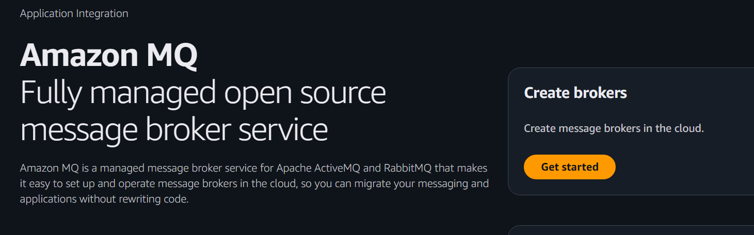Broker Engine
ActiveMQ
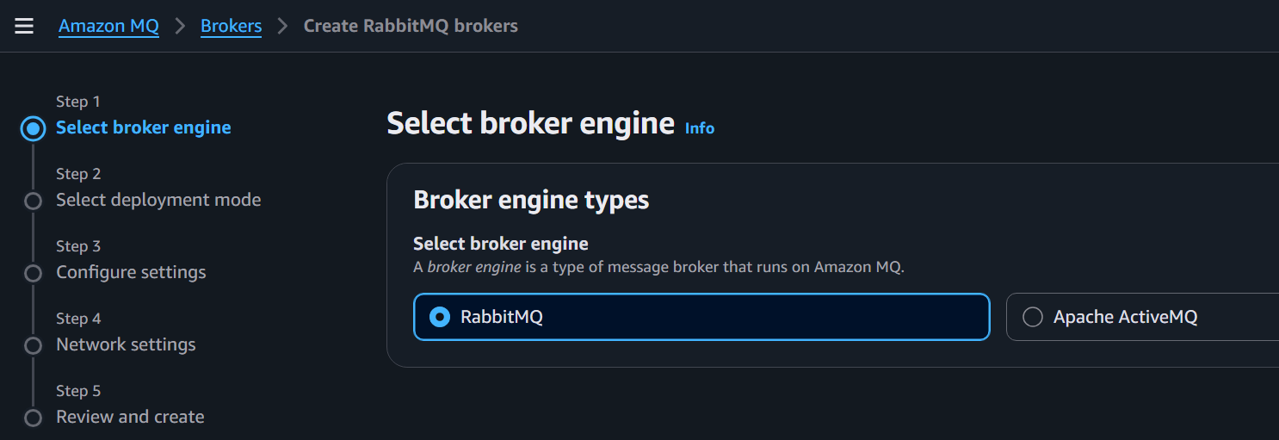

Deployment Mode
Single Instance
(Free Tier Eligible where available)
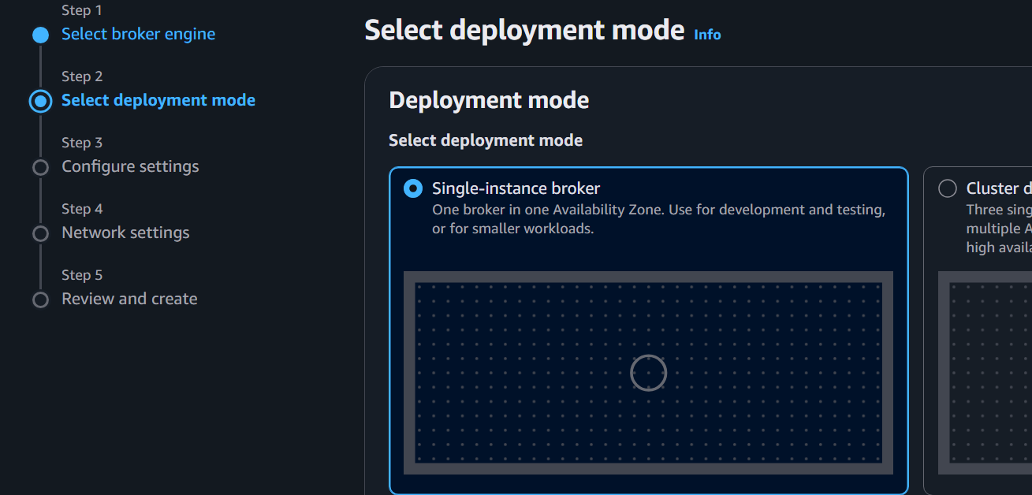

Broker Name
DevOpsBroker
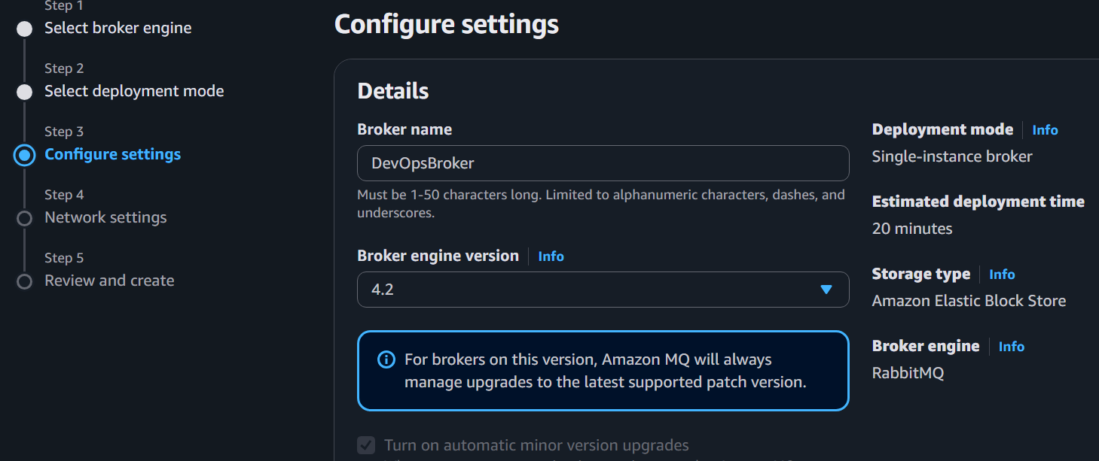

Username
admin
Password
DevOps@12345
(Create a strong password of your choice.)
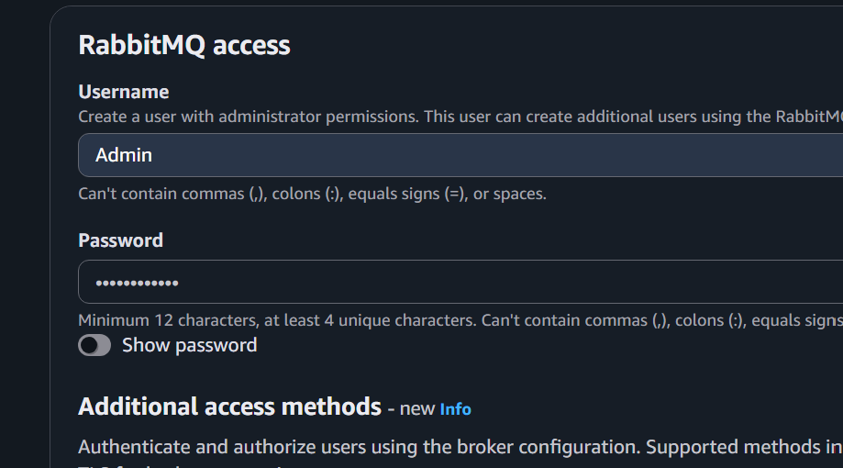

Broker Instance Type
mq.t3.micro
(if available in your account/region)

Storage
EFS
(Default managed storage)

Click
Next

Choose
Default VPC
Default Security Group (or create one allowing required broker ports only)
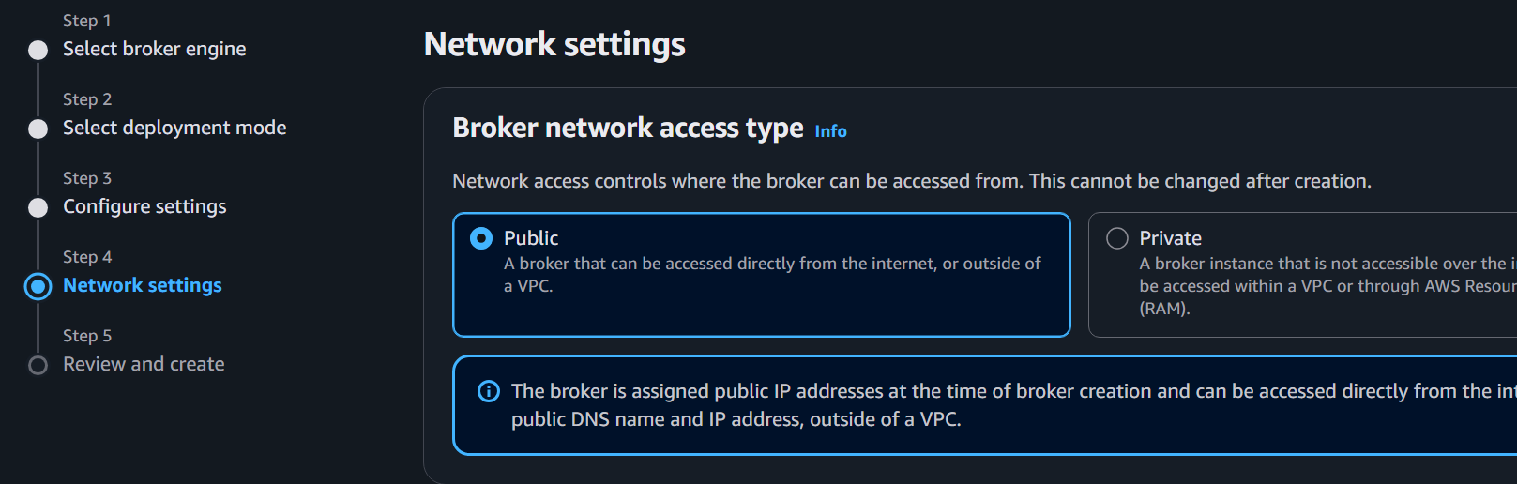

Click
Create Broker
Provisioning may take 15–30 minutes.
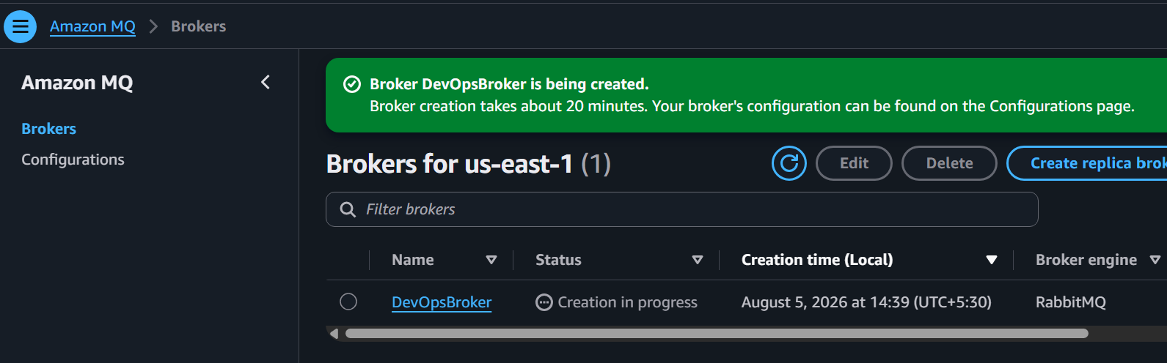
Broker Creation

Task 2 – Verify Broker
Status should become
Running
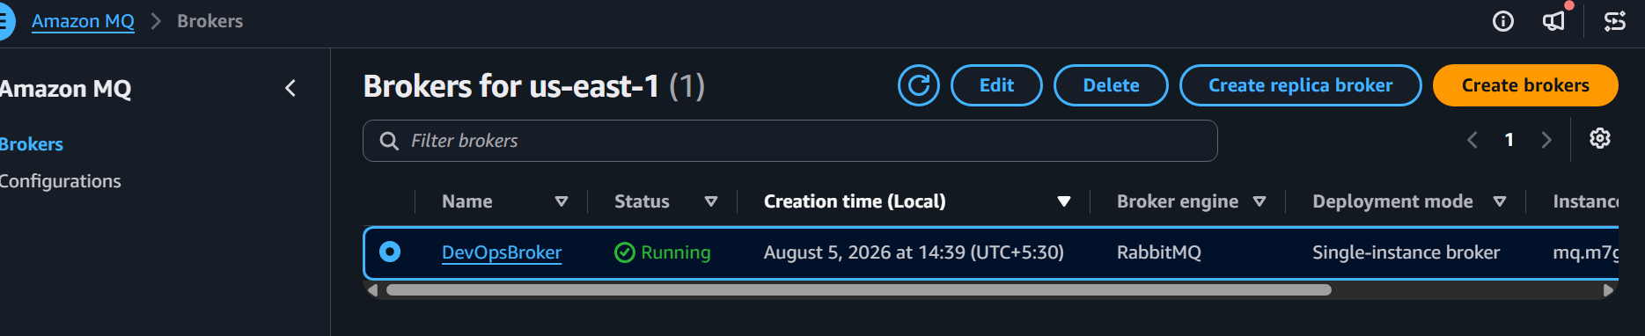
Task 3 – Create Queue in ActiveMQ Web Console
Open Broker
↓
Connections
↓
Web Console URL
Log in using broker credentials.
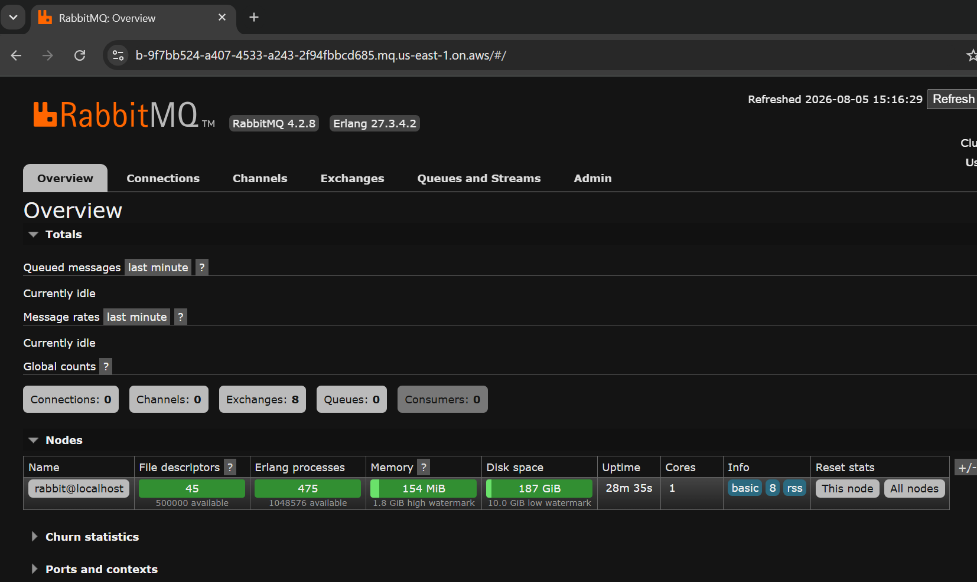
Create Queue
OrdersQueue
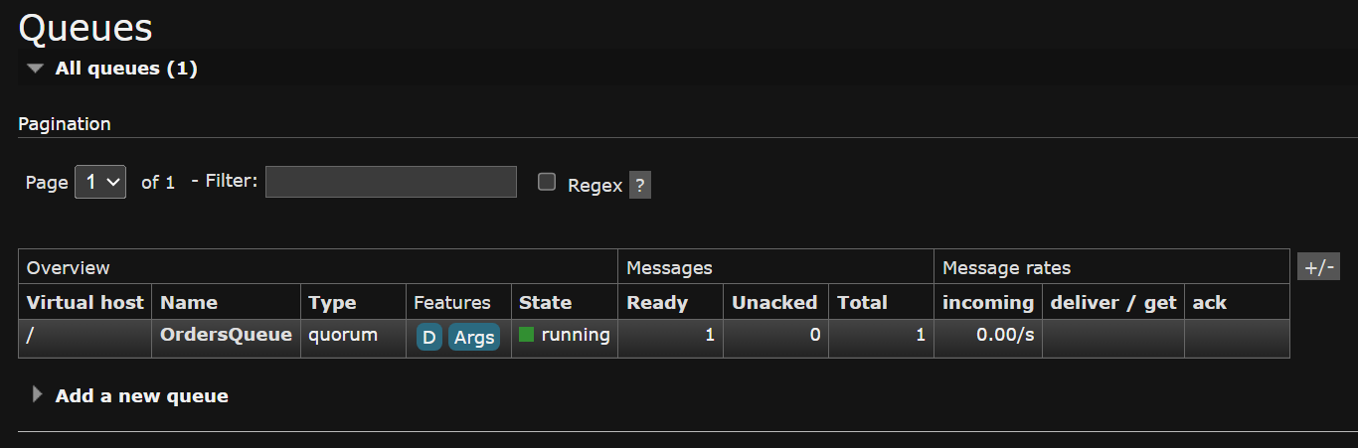

Task 4 – Send Message
In Web Console
↓
OrdersQueue
↓
Send Message
Hello Amazon MQ
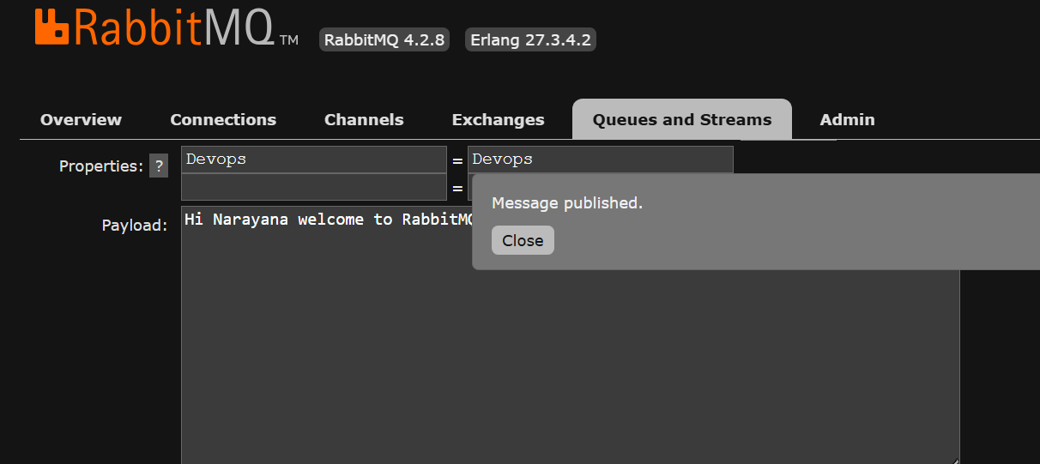
Message Sent
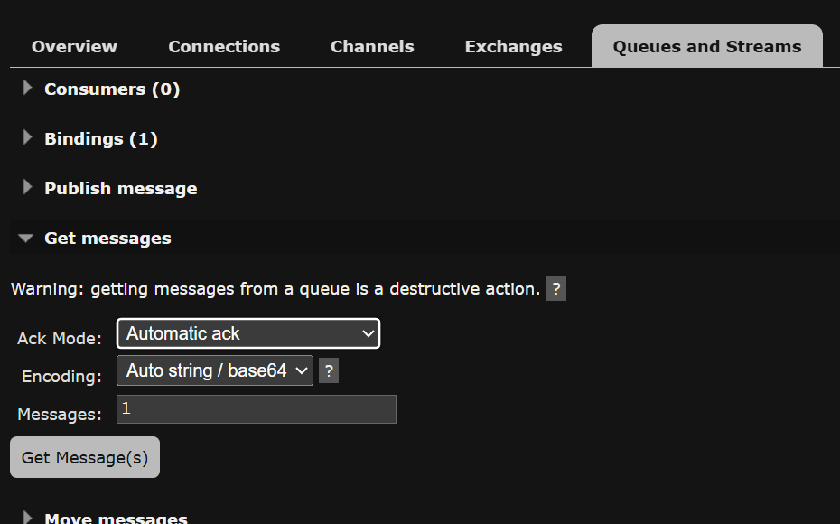
Task 5 – Consume Message
Receive/Browse Messages
Verify the message is available or consumed depending on the operation.
Consumer Output
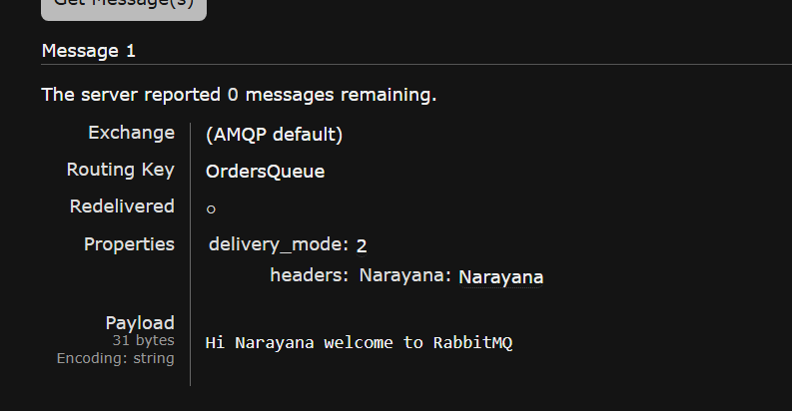
Task 7 – Delete Broker
Delete broker after testing to avoid charges.
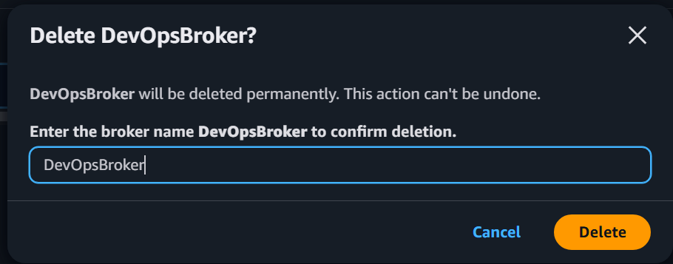
Broker Deleted
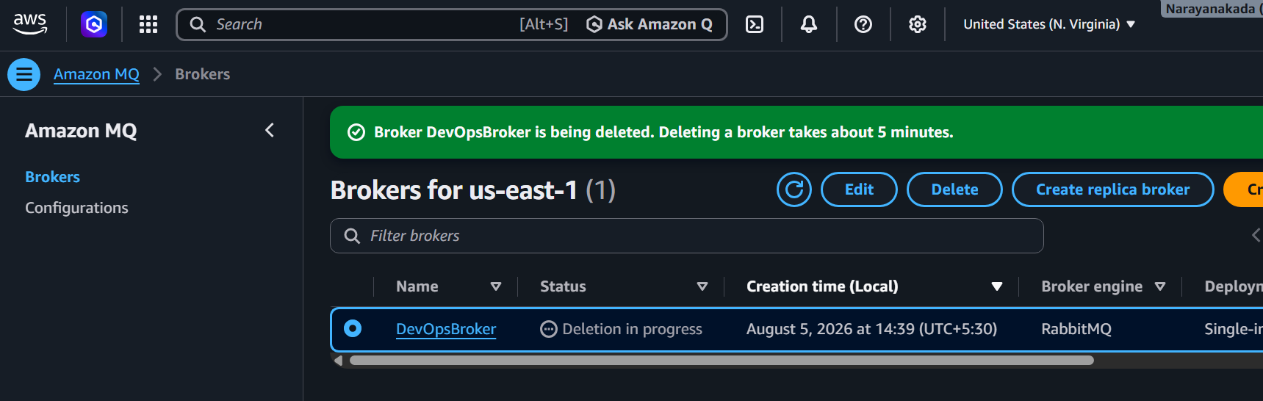

Observations
- Amazon MQ supports standard messaging protocols.
- Suitable for migrating legacy applications.
- Managed service reduces operational effort.
- Supports high availability options.
- Integrates with VPC networking and IAM.

Advantages
- Managed Broker
- Enterprise Ready
- High Availability Options
- Supports JMS, AMQP, MQTT, STOMP (engine-dependent)
- Secure

Disadvantages
- More expensive than SQS for simple queueing
- Broker management concepts still apply
- Startup time longer than SQS

AWS MQ vs Amazon SQS
Feature | Amazon SQS | Amazon MQ
Service Type | Message Queue | Managed Message Broker
Management | Fully Managed | Managed Broker
Ordering | FIFO available | Broker-managed
Protocol Support | AWS API | JMS, AMQP, MQTT, STOMP (engine-dependent)
Best For | Cloud-native applications | Legacy and enterprise applications
Scalability | Automatic | Depends on broker configuration
Persistence | Yes | Yes
High Availability | Built-in | Configurable

AWS Secrets Manager
What is AWS Secrets Manager?
AWS Secrets Manager is a fully managed service that helps you securely store, manage, retrieve, and rotate secrets throughout their lifecycle.
Instead of storing passwords or API keys directly in your application code, applications retrieve them securely from Secrets Manager.
Why Do We Need Secrets Manager?
Without Secrets Manager:
Application
│
▼
Username = admin
Password = Password123
(API key stored in code)
Problems:
- Passwords are visible in the source code.
- Difficult to update passwords.
- Security risks if the code repository is exposed.
With Secrets Manager:
Application
│
▼
AWS Secrets Manager
│
▼
Encrypted Secret
Benefits:
- Secrets are encrypted.
- Easy to rotate.
- Centralized management.
- IAM-controlled access.
- Audit logging with CloudTrail.
Real-World Use Cases
1. Database Credentials
Store:
- MySQL Username
- MySQL Password
Application retrieves credentials securely at runtime.2. Third-Party APIs
Store:
- Stripe API Key
- Razorpay Secret
- PayPal Secret
3. AWS Access Keys
Securely store access keys for automation or legacy integrations (when such keys are required).4. SSH Keys
Store private keys securely.5. OAuth Tokens
Store OAuth client secrets and refresh tokens.
Services Used
- AWS Secrets Manager
- AWS KMS
- IAM
- Amazon RDS (Optional)
- AWS CloudTrail (Optional for auditing)
Architecture
IAM User
│
▼
AWS Secrets Manager
│
Encrypted by AWS KMS
│
▼
Database / Application
Prerequisites
- AWS Account
- IAM User with appropriate permissions
- AWS Region selected (for example, us-east-1)

Hands-on Lab
Task 1 – Open AWS Secrets Manager
- Sign in to the AWS Management Console.
- Search for Secrets Manager.
- Open AWS Secrets Manager.
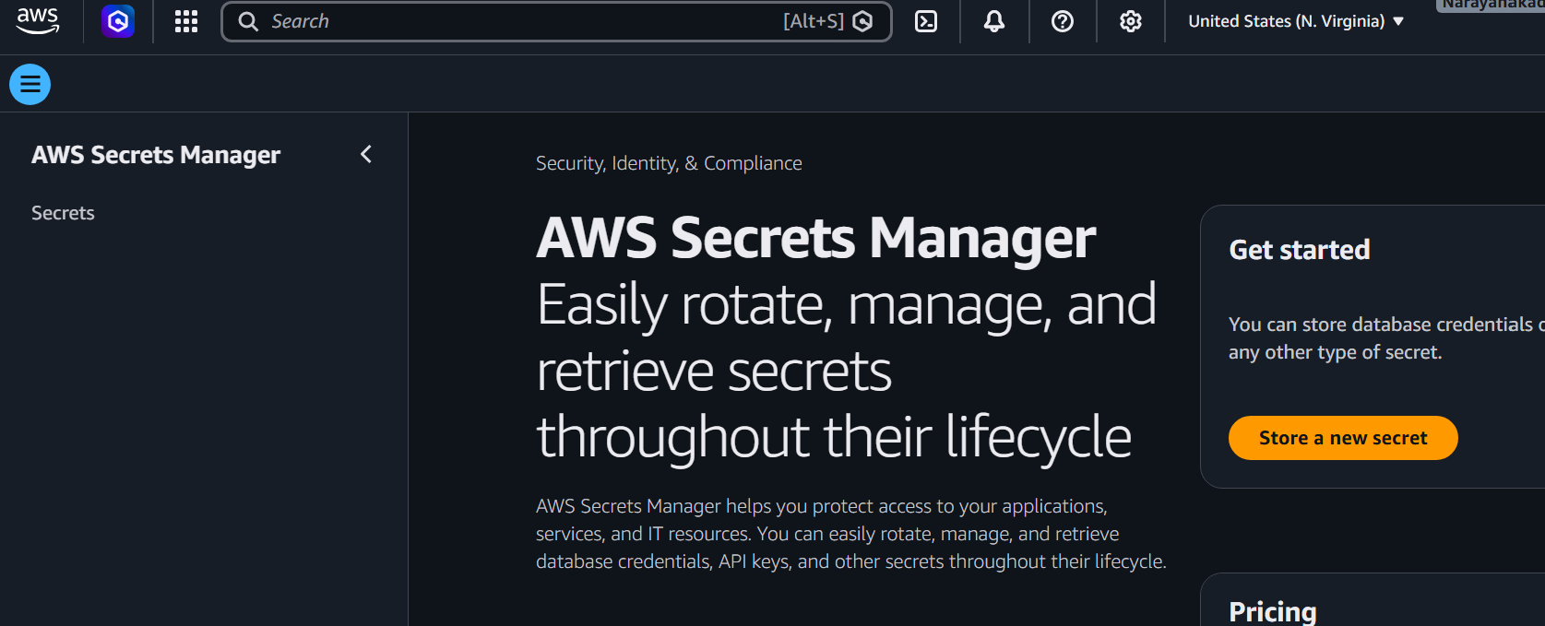
- Click Store a new secret.
Capture the Secrets Manager Home Page.

Task 2 – Choose Secret Type
You will see several options.
Select:
Other type of secret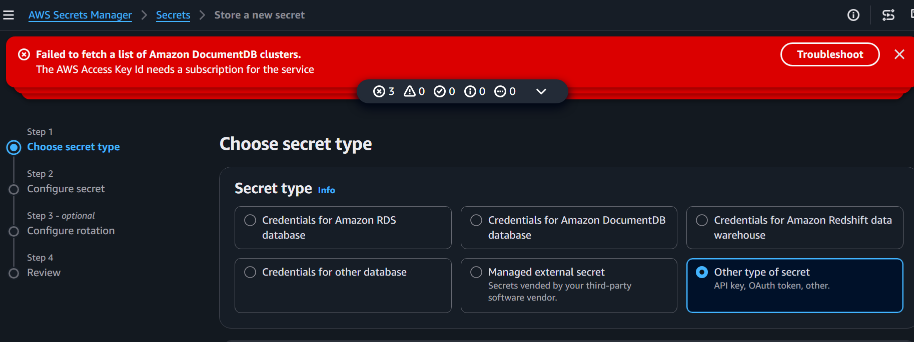
This allows you to create custom key-value pairs.
Task 3 – Create Secret
Under Key/Value pairs, enter:
Key | Value
Username | admin
Password | DevOps@123
Environment | Production
You can add more keys if required.
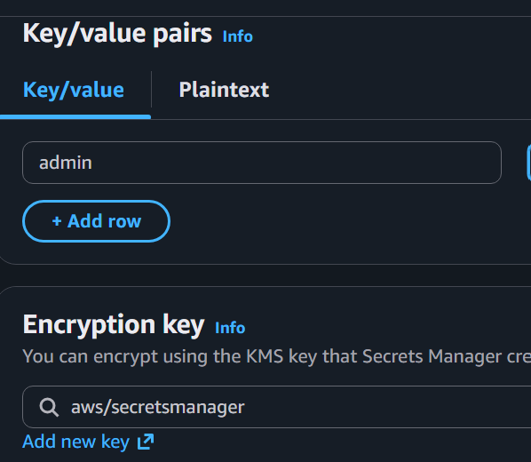
Example:
Key | Value
APIKey | ABCD123456789
Region | us-east-1
Click Next.
Capture the Key-Value Secret Details.
Task 4 – Configure Encryption
Secrets Manager automatically encrypts secrets using AWS KMS.
Keep:
AWS Managed Key
aws/secretsmanager
(Alternatively, you may choose a customer-managed KMS key if you have created one.)
Click Next.
Task 5 – Name the Secret
Enter:
Secret Name
DevOps-App-Secret
Description:
Stores application credentials for DevOps lab.
Click Next.
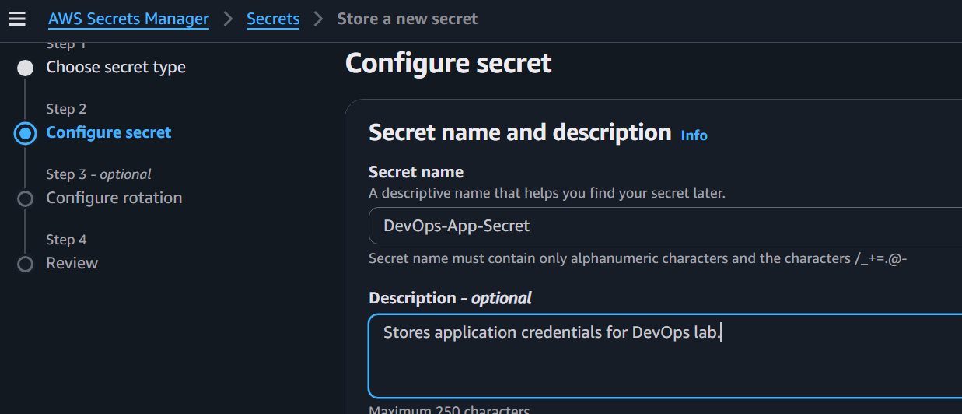
Task 6 – Configure Rotation
For this lab:
Leave Automatic Rotation Disabled.
Click Next.
Note: Automatic rotation generally requires a supported database or a custom rotation function using AWS Lambda.
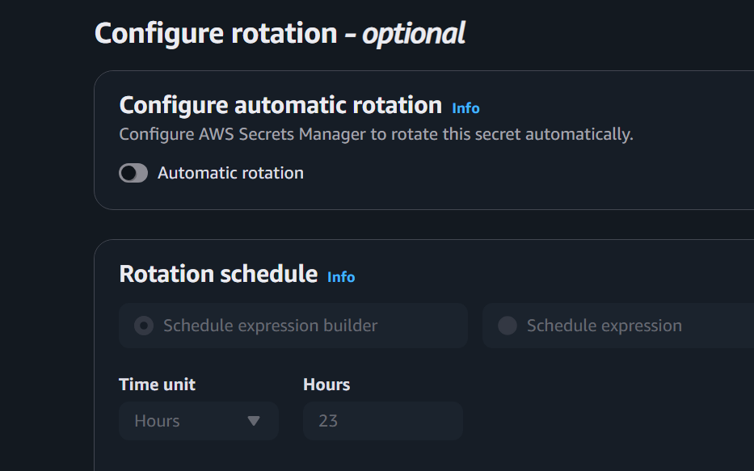
Task 7 – Review
Review:
- Secret Name
- Encryption
- Secret Values
- Rotation Settings
Click Store.
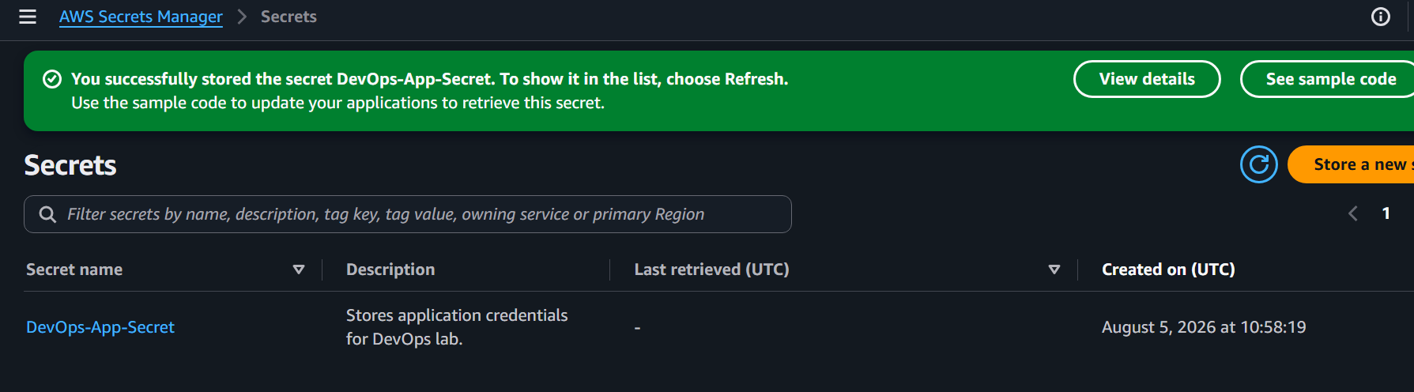
Task 8 – Verify Secret
Open the newly created secret.
Verify that it appears in the list.
Status:
Available
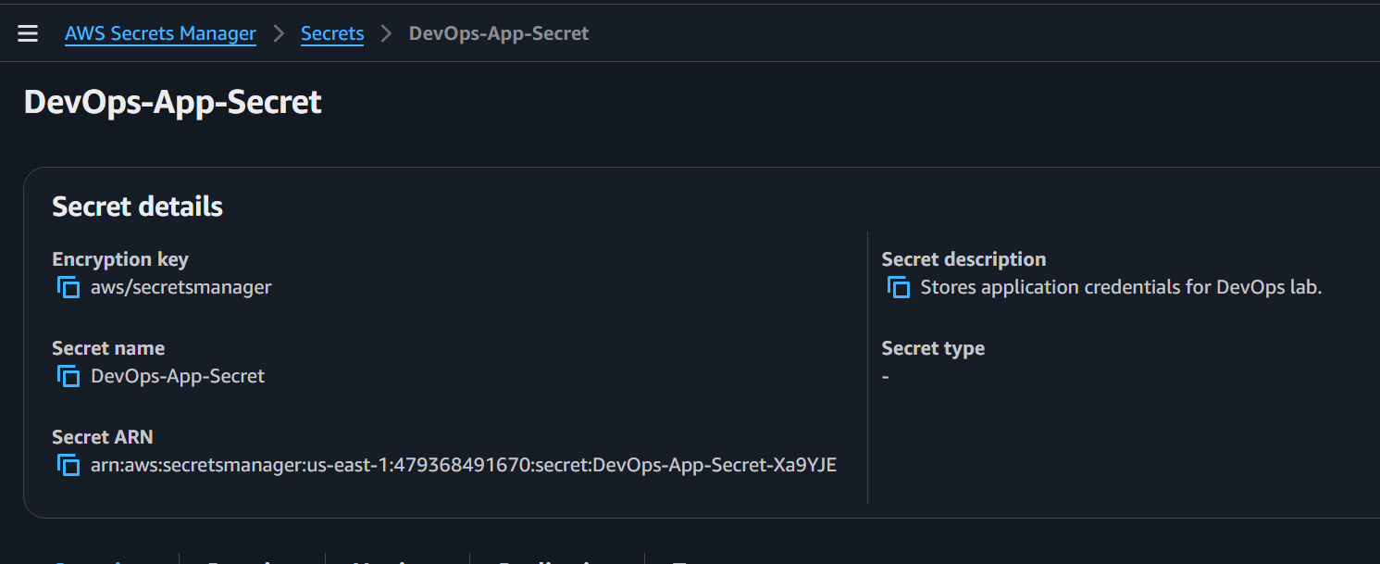

Task 9 – Retrieve the Secret
Open the secret.
Click Retrieve secret value.
You should see:
Username : admin
Password : DevOps@123
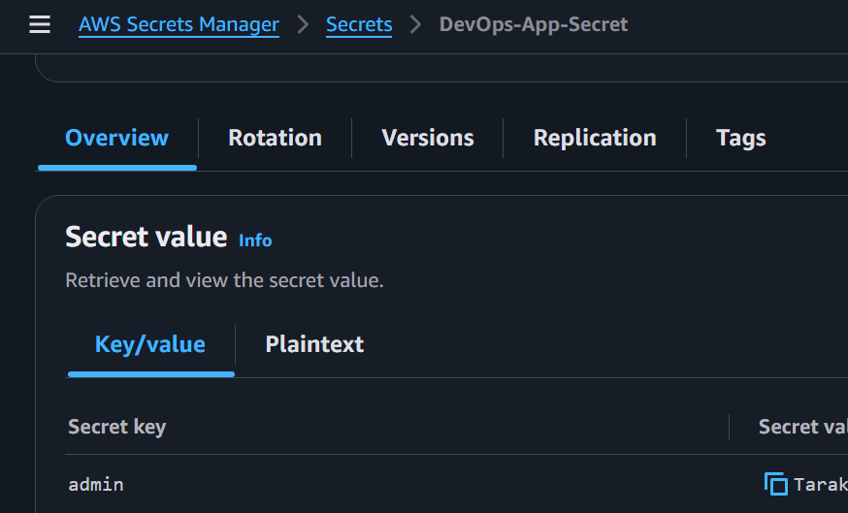
Click close to Hide secret value after verification.

Task 10 – Edit the Secret
Click Edit.
Change:
Password
From
DevOps@123
To
DevOps@2026
Click Save.
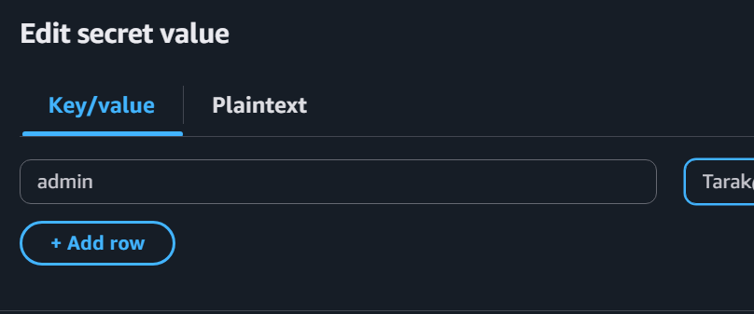
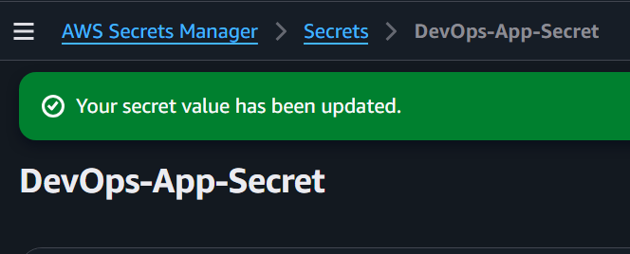
Capture the Updated Secret.
Task 11 – View Secret Versions
Open the secret.
Select the Versions tab.
You should see:
- Current Version
- Previous Version (if applicable)
This demonstrates versioning after updating a secret.
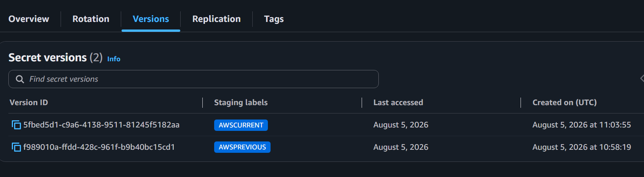
Task 12 – Review Resource Policy (Optional)
Open the Permissions tab.
Review the resource policy.
You may leave the default configuration if you do not need cross-account access.
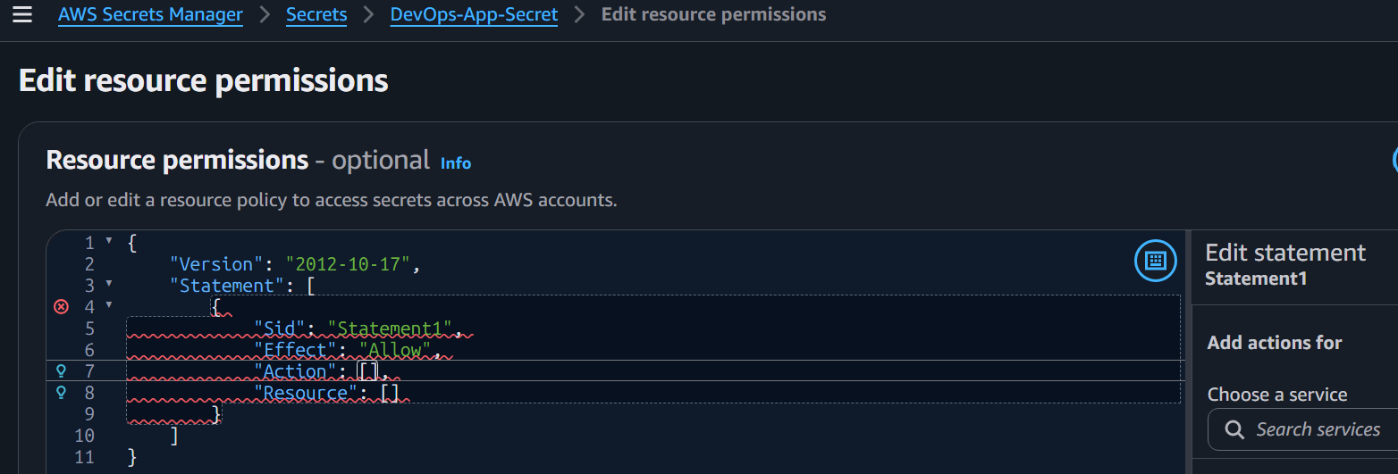
Task 13 – Review CloudTrail Events (Optional)
Open CloudTrail.
Go to Event history.
Filter by:
secretsmanager.amazonaws.com
Verify events such as:
- CreateSecret
- PutSecretValue
- UpdateSecret
- GetSecretValue (if recorded through supported operations)
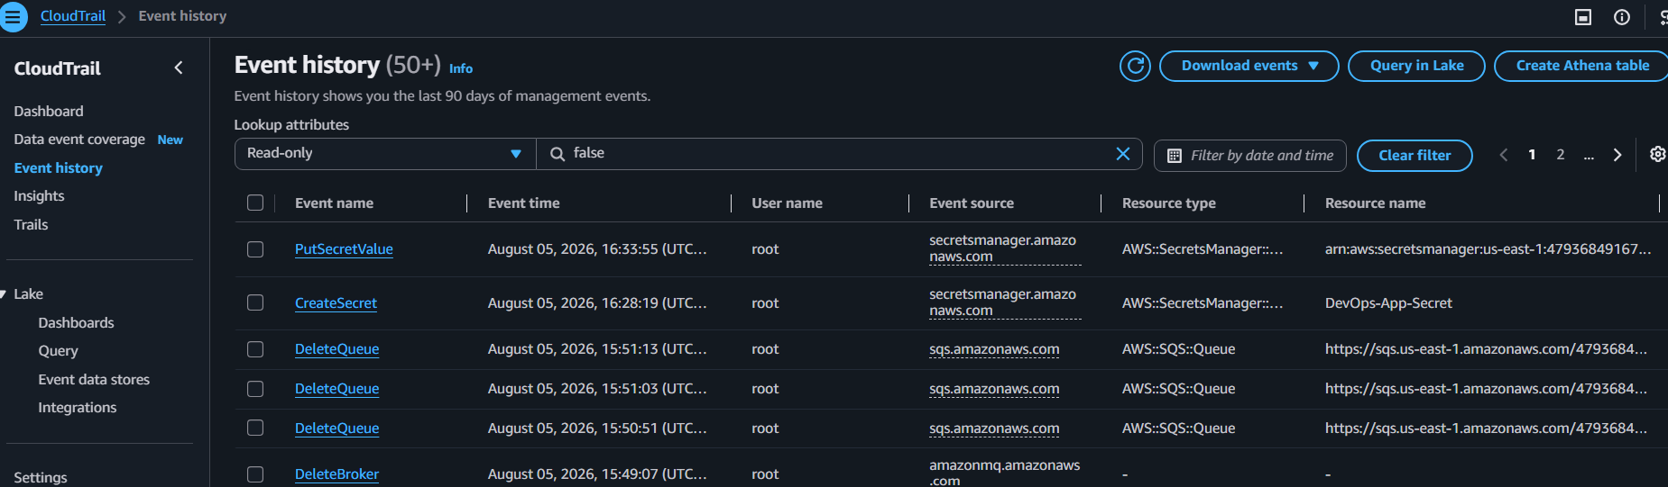
Task 14 – Delete the Secret (Optional Cleanup)
If this lab is complete:
- Select the secret.
- Click Delete.
- Specify the recovery window (for example, 7 days).
- Confirm deletion.
AWS Secrets Manager schedules deletion; the secret is not removed immediately.
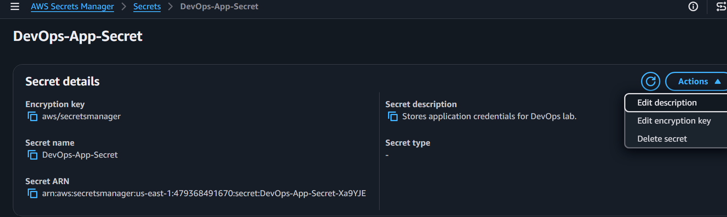
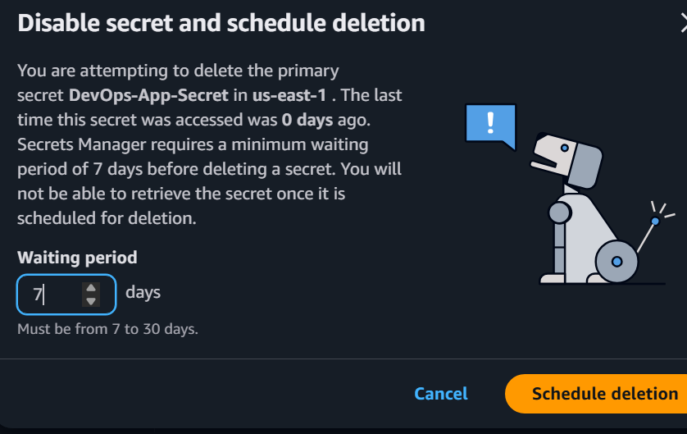

If we want to edit encryption key we can edit the encryption key
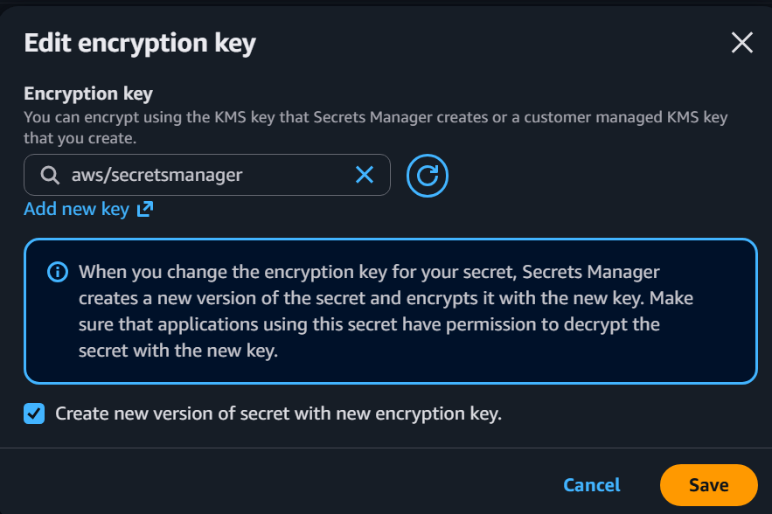
Observations
- Secrets were securely stored using AWS Secrets Manager.
- Secrets were encrypted automatically using AWS KMS.
- Secret values could be retrieved only after appropriate permissions were granted.
- Updating a secret created a new version.
- CloudTrail can record management actions for auditing.
- Secrets can be recovered during the configured deletion recovery window.

Advantages
- Secure storage of passwords and API keys.
- Automatic encryption using AWS KMS.
- Secret versioning.
- Fine-grained IAM access control.
- Optional automatic rotation.
- CloudTrail integration for auditing.
- Reduces the risk of exposing credentials in source code.

Disadvantages
- Monthly charges apply per secret and API usage.
- Automatic rotation requires additional setup (typically AWS Lambda and supported services).
- Misconfigured IAM policies can prevent applications from accessing secrets.
- Cross-account access requires additional policy configuration.

